Appendix-3: Facility Numbers
# | Program Title | Submitting Hospital | Facility Number
2 | a) Sarcoma (Chemotherapy)  b) Sarcoma (Pathology)  c) Sarcoma (Prosthesis) | Royal Victoria Regional Health Center | 606
 |  | Kingston Health Sciences Centre (KHSC) | 978
 |  | Grand River Health Corporation | 930
 |  | Windsor Regional Center | 933
 |  | Thunder Bay Regional Health Sciences Centre | 935
 |  | London Health Sciences | 936
 |  | Hamilton Health Sciences Corporation | 942
 |  | University Health Network | 947
 |  | Sunnybrook Health Sciences Centre | 953
 |  | The Ottawa Hospital | 958
 |  | Health Sciences North | 959
 |  | Sinai Health System | 976

Appendix-11: Valid 2-digits Postal Codes
(Source: Cancer Care Ontario's Data Book - 2012-2013, Appendix B - Province and State codes, at link https://www.cancercare.on.ca/ext/databook/db1213/databook.htm).

The table below provides list of valid 2 digit postal codes for province and State codes.

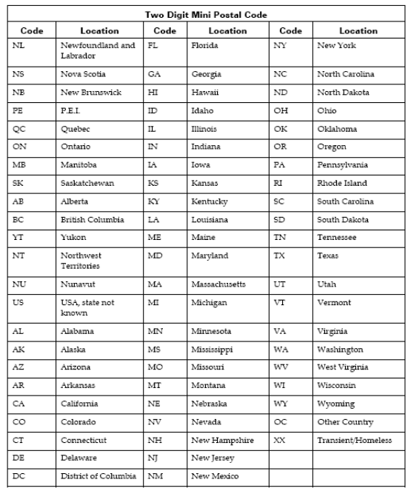

Appendix-14: Valid Drug Names
Valid Drug Names
Cisplatin
Cyclophosphamide
Docetaxel
Doxorubicin
Epirubicin
Etoposide
Gemcitabine
High Dose Ifosfamide
High Dose Methotrexate
Ifosfamide
Mesna
Methotrexate
Other
Topotecan
Vinblastine
Vincristine
Vinorelbine

Appendix-22: Pharmaceutical dose unit
This table provides info for Radio pharmaceutical dose unit

Unit  Code | Description
cap | capsule
MBq | megabecquerels
mcg | microgram
mEq | milliequivalent
MU | million units
tab | tablet
unit | unit
mg | milligram
mL | milliliter
drop | drop
pfu | plaque forming unit
cm | centimeter
g | gram
loz | lozenge
mmol | millimoles
part | particle
ptch | patch
pkt | packet
pop | popsicle
puff | puff
spry | spray
supp | suppository

Appendix-23: Regimen List
A set of anti-cancer and supportive medications given during an active course of systemic chemotherapy that is named and defined in CCO's Provincial Formulary Regimen List.

Regimen Name | Description
CISPDOX-MTRX(HD) | OSTEOGENIC SARCOMA (CISPLATIN,DOXORUBICIN,METHOTREXATE)
CYCLTOPO | SARCOMA OR NEUROBLASTOMA - TOPOTECAN, CYCLOPHOSPHAMIDE
DOCEGEMC | GI,PANCREAS OR LUNG,NSCLC OR GU,BLADDER OR GYNECOLOGICAL OR BREAST OR HEMATOLOGY OR HEAD AND NECK OR SARCOMA - GEMCITABINE, DOCETAXEL
DOXOIFOS | SARCOMA OR GYNECOLOGICAL, IFOSFAMIDE-DOXORUBICIN (+ MESNA)
EPIRIFOS | SOFT TISSUE SARCOMA (IFOSFAMIDE,EPIRUBICIN,MESNA)
ETOPIFOS | SARCOMA, IFOSFAMIDE-ETOPOSIDE (MAY USE MESNA)
GEMC | GI,PANCREAS OR LUNG,NSCLC OR GU,BLADDER OR GYNECOLOGICAL OR BREAST OR HEMATOLOGY OR HEAD AND NECK OR SARCOMA - GEMCITABINE
IFOS | SARCOMA OR GYNECOLOGICAL OR GENITOURINARY, IFOSFAMIDE (+ MESNA)
IFOS(HD) | SARCOMA - IFOSFAMIDE (HIGH DOSE) (+ MESNA)
MTRX(HD) | GYNECOLOGICAL - GESTATIONAL TROPHOBLASTIC NEOPLASIA OR HEMATOLOGY OR SARCOMA OR UNKNOWN OR CNS, METHOTREXATE (> OR = 100MG/M2))
MTRXVINO | SARCOMA -SOFT TISSUES, VINORELBINE - METHOTREXATE
MTRXVNBL | SARCOMA -SOFT TISSUES, VINBLASTINE - METHOTREXATE
VAC | GYNECOLOGIC SARCOMA (vinCRIStine; DOXOrubicin; Cyclophosphamide)

